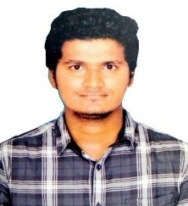

**ACADEMIC CAREER**

**Dec’2019 – Feb’2020**: Front – End Developer at Script IT Solutions, Bangalore.

* Developed CRM for a finance company using HTML, CSS and React JS framework.

**Mar’2020 – Present**: Front – End Developer at Jivox Software India Pvt Ltd., Bangalore.

* Developed remarkable digital ads using JavaScript, HTML5, CSS3 and jQuery.
* Have built both prospecting and retargeting campaigns along with hands-on experience in Jivox IQ platform.
* Worked with animate cc files.

**2019:** Completed B. E in Computer Science and Engineering from S.A Engineering College, Chennai.

**CERTIFICATION**

Completed Full Stack Developer Course at GUVI, IITM.

**ACHIEVEMENTS**

**LANGUAGES**

BrainOBrain Abacus Topper in National Meet held at Chennai.

* English - Full Professional Proficiency
* Tamil - Full Professional Proficiency
* Telugu - Native or Bilingual Proficiency

*gbnagayugesh@gmail.com*

Cricket

Chess

Reading

**HOBBIES**

Extrovert

Communication Skills

Flexible

CSS3

jQuery





JavaScript

HTML

**SOFT SKILLS**

 

**EXPERTISE**

Passionate Front-End Developer with an overall experience of 1.3 years seeking to leverage my professional expertise and strong interpersonal skills to secure a job as a Creative Developer.

**WORK EXPERIENCE**

+91 90875 51844

**NAGA YUGESH G B**

**ABOUT ME**